# EXPERIMENT NO. 1

## AIM

To study various DDL commands - CREATE

# Question

Create the following Tables

## Table 1: DEPOSIT

ACTNO VARCHAR2(5) PRIMARY KEY, FIRST LETTER MUST START WITH ‘D’ CNAME VARCHAR2(15) FOREIGN KEY REFERENCES CUSTOMER

BNAME VARCHAR2(20) FOREIGN KEY REFERENCES BRANCH AMOUNT NUMBER (8,2) NOT NULL, CANNOT BE 0

ADATE DATE

create table deposit(acno varchar(5) check(acno like 'd%')primary key,cname varchar(15)references customer(cname),bname varchar(20)references branch(bname),amount float(8) check(amount>0)not null,adate date)

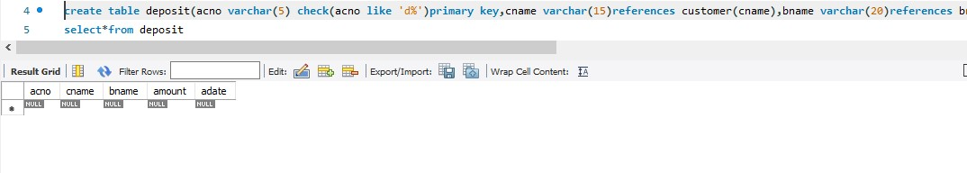

## Table 2: BRANCH

BNAME VARCHAR2(20) PRIMARY KEY

CITY VARCHAR2(30) NOT NULL , any one of NAGPUR, DELHI, BANGALORE, BOMBAY

create table branch(bname varchar(20) primary key,city varchar(30) check(city in('nagpur','delhi','banglore','bombay'))not null);

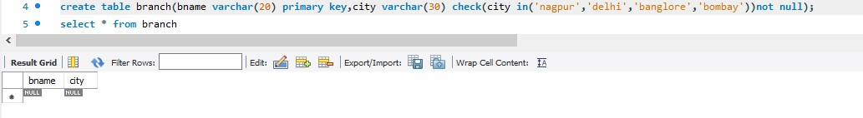

## Table 3: CUSTOMER

CNAME VARCHAR2(15) PRIMARY KEY CITY VARCHAR2(20) NOT NULL

create table customer(cname varchar(15) primary key,city varchar(20) not null)

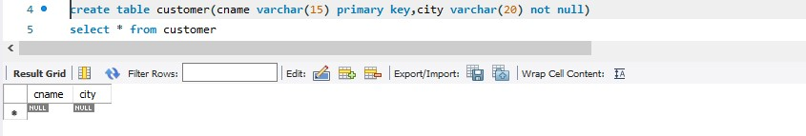

## Table 4: BORROW

LOANNO VARCHAR2(8) PRIMARY KEY / FIRST LETTER MUST START WITH ‘L’ CNAME VARCHAR2(15) FOREIGN KEY REFERENCES CUSTOMER

BNAME VARCHAR2(20) FOREIGN KEY REFERENCES BRANCH AMOUNT NUMBER(8,2) NOT NULL, CANNOT BE 0

create table borrow(loanno varchar(8) check(loanno like 'l%')primary key,cname varchar(15)references customer(cname),bname varchar(20)references branch(bname),amount float(8)check(amount>0)not null)

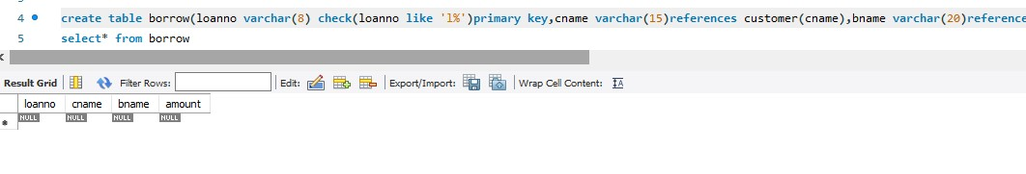

**INSERTION OF VALUES**

1. **Inserting values to Branch**

|  |  |
| --- | --- |
| VRCE | NAGPUR |
| AJNI | NAGPUR |
| KAROLBAGH | DELHI |
| CHANDNI | DELHI |
| DHARAMPETH | NAGPUR |
| MG ROAD | BANGALORE |

|  |  |
| --- | --- |
| ANDHERI | BOMBAY |
| NEHRU PALACE | DELHI |
| POWAI | BOMBAY |

insert into branch values('MG ROAD','BANGLORE');

insert into branch values('DHARAMPETH','NAGPUR');

insert into branch values('CHANDNI','DELHI');

insert into branch values('KAROLBAGH','DELHI');

insert into branch values('AJNI','NAGPUR');

insert into branch values('VRCE','NAGPUR');

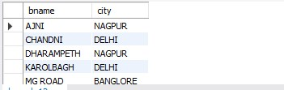

1. **Inserting values into Customer table**

|  |  |
| --- | --- |
| ANIL | CALCUTTA |
| SUNIL | DELHI |
| MEHUL | BARODA |
| MANDAR | PATNA |
| MADHURI | NAGPUR |
| PRAMOD | NAGPUR |
| SANDIP | SURAT |
| SHIVANI | BOMBAY |
| KRANTI | BOMBAY |
| NAREN | BOMBAY |

insert into branch values('VRCE','NAGPUR');

insert into customer values('NAREN','BOMBAY');

insert into customer values('KRANTI','BOMBAY');

insert into customer values('SHIVANI','BOMBAY');

insert into customer values('SANDIP','SURAT');

insert into customer values('PRAMOD','NAGPUR');

insert into customer values('MADHURI','NAGPUR');

insert into customer values('MANDAR','PATNA')

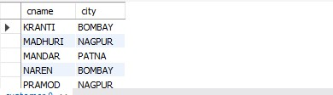

1. **Inserting values into Deposite table**

|  |  |  |  |  |
| --- | --- | --- | --- | --- |
| Actno | Cname | Bname | Amount | Adate |
| D100 | ANIL | VRCE | 1000.00 | 1-MAR-95 |
| D101 | SUNIL | ANJNI | 500.00 | 4-JAN-96 |
| D102 | MEHUL | KAROLBAGH | 3500.00 | 17-NOV-95 |
| D104 | MADHURI | CHANDNI | 1200.00 | 17-DEC-95 |
| D105 | PRAMOD | MG ROAD | 3000.00 | 27-MAR-96 |
| D106 | SANDIP | ANDHERI | 2000.00 | 31-MAR-96 |
| D107 | SHIVANI | VIRAR | 1000.00 | 5-SEP-95 |
| D108 | KRANTI | NEHRU  PLACE | 5000.00 | 2-JUL-95 |
| D109 | MINU | POWAI | 7000.00 | 10-AUG-95 |

insert into deposit values('D109','MINU','POWAI',7000.00,'95-08-10')

insert into deposit values('D108','KRANTI','NEHRU PLACE',5000.00,'95-07-02')

insert into deposit values('D107','SHIVANI','VIRAR',1000.00,'95-09-05')

insert into deposit values('D106','SANDIP','ANDHERI',2000.00,'96-03-31')

insert into deposit values('D105','PRAMOD','MG ROAD',3000.00,'96-03-27')

insert into deposit values('D104','MADHURI','CHANDNI',1200.00,'95-12-17')

insert into deposit values('D102','MEHUL','KAROLBAGH',3500.00,'95-11-17')

insert into deposit values('D101','SUNIL','ANJNI',500.00,'96-01-04')

insert into deposit values('D100','ANIL','VRCE',1000.00,'1995-03-01')

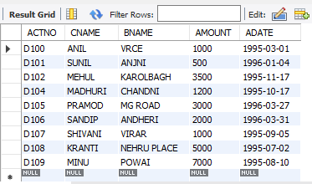

1. **Inserting values into borrow table**

|  |  |  |  |
| --- | --- | --- | --- |
| L201 | ANIL | VRCE | 1000.00 |
| L206 | MEHUL | AJNI | 5000.00 |
| L311 | SUNIL | DHARAMPETH | 3000.00 |
| L321 | MADHURI | ANDHERI | 2000.00 |
| L371 | PRAMOD | VIRAR | 8000.00 |
| L481 | KRANTI | NEHRU PLACE | 3000.00 |

insert into borrow values('L481','KRANTI','NEHRU PLACE',3000.00)

insert into borrow values('L371','PRAMOD','VIRAR',8000.00)

insert into borrow values('L321','MADHURI','ANDHERI',2000.00)

insert into borrow values('L311','SUNIL','DHARAMPETH',3000.00)

insert into borrow values('L206','MEHUL','AJNI',5000.00)

insert into borrow values('L201','ANIL','VRCE',1000.00)

